SIMATS ENGINEERING

ASSESSMENT TOOL 2

COURSE NAME: Database Management Systems COURSE CODE: CSA05

NAME:PASAM MURALI KRISHNA

REG NO:192525178

COURSE OUTCOME COVERED

CO1: Analyze DBMS architecture, different data models, schema types, and design ER/EER diagrams, relational schemas for case-based scenarios by identifying entities and relationships. (BL1, BL2)

Activity Tool : Concept Mapping (Medium) Assessment Tool Weightage: 35%

Dr

QUESTIONS Total Marks: 50
Q.No | Question | Bloom's Level | Marks
1 | Construct a concept map linking the following terms: DBMS, Schema, Instance, Data Model, ER Diagram, Entity, Attribute, Relationship. | BL2 – Understand | 5
2 | Create a concept map for the three-level ANSI/SPARC architecture showing data independence at each level. | BL2 – Understand | 5
3 | Map the relationship between file-based systems and database systems, highlighting the problems solved by DBMS. | BL2 – Understand | 5
4 | Design a concept map for ER diagram components: entity, weak entity, attribute types, relationship types, and participation constraints. | BL2 – Understand | 5
5 | Construct a concept map comparing Hierarchical, Network, and Relational data models with their key properties. | BL2 – Understand | 5
6 | Develop a concept map for the EER model showing how it extends the basic ER model with generalization, specialization, and aggregation. | BL2 – Understand | 5
7 | Create a visual concept map for the DBMS software architecture, illustrating the flow from user request to data retrieval. | BL2 – Understand | 5

8 | Map the data models discussed in CO1 to real-world applications and explain the suitability of each model. | BL2 – Understand | 5
9 | Construct a concept map for schemas and instances, showing how they relate to physical and logical data independence. | BL2 – Understand | 5
10 | Design a concept map for the roles and responsibilities in a DBMS environment: DBA, End User, Application Developer. | BL1 – Remember | 5

Code of Conduct:

I P.Murali Krishna(192525178) certify that this submission is my original work and that I have adhered to the guidelines specified for this assessment. I understand that any violation of academic integrity rules will result in disciplinary action.

Signature of the student: 

RUBRICS FOR CALCULATION:

Criteria | Weightage | Level 4 (Exemplary) | Level 3 (Proficient) | Level 2 (Developing) | Level 1 (Beginning)
Concept Identification | 25% | Identifies all key concepts from literature accurately and comprehensively | Identifies most key concepts with minor omissions | Identifies limited concepts; some are irrelevant or missing | Fails to identify essential  concepts
Linkages | 25% | Establishes clear, meaningful, and accurate relationships between concepts | Shows correct relationships with minor gaps | Relationships are weak, unclear, or partially incorrect | No meaningful relationships established
Organization | 20% | Concepts are well-structured hierarchically with logical flow and grouping | Mostly organized with minor structural issues | Some organization but lacks clear hierarchy | No logical organization or structure
Integration of Literature | 20% | Integrates multiple studies effectively to  show connections and comparisons | Shows some integration of literature | Limited integration; mostly isolated concepts | No integration of literature evidence

Clarity | 10% | Concept map is clear, neat, visually structured, and easy to interpret | Generally clear with minor readability issues | Clarity is reduced; difficult to interpret in parts | Poorly presented and hard to understand
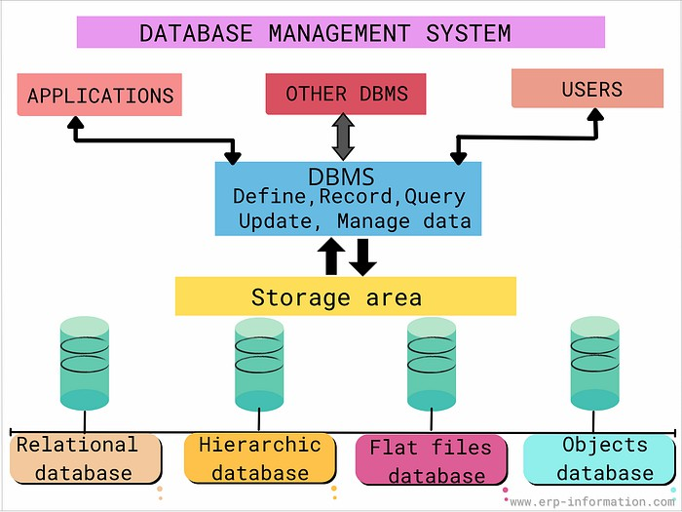

1. Construct a concept map linking the following terms: DBMS, Schema, Instance, Data Model, ER Diagram, Entity, Attribute, Relationship.
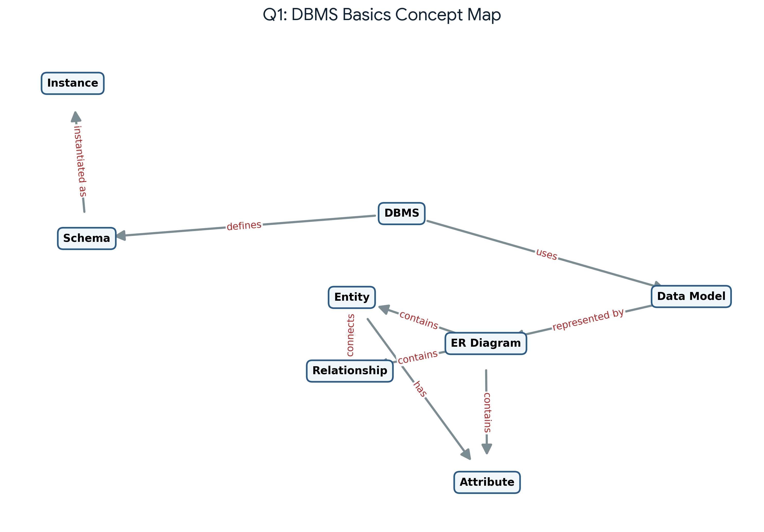
Explanation: This concept map illustrates the core foundational concepts in Database Management Systems (DBMS). The DBMS uses a Data Model (represented visually through ER Diagrams) to structure data. It defines the Schema (the overall design), which is populated with data at a specific moment, known as an Instance. In the ER Model context, Entities represent real-world objects, which possess characteristics called Attributes, and are connected to one another through Relationships.

2. Create a concept map for the three-level ANSI/SPARC architecture showing data independence at each level.
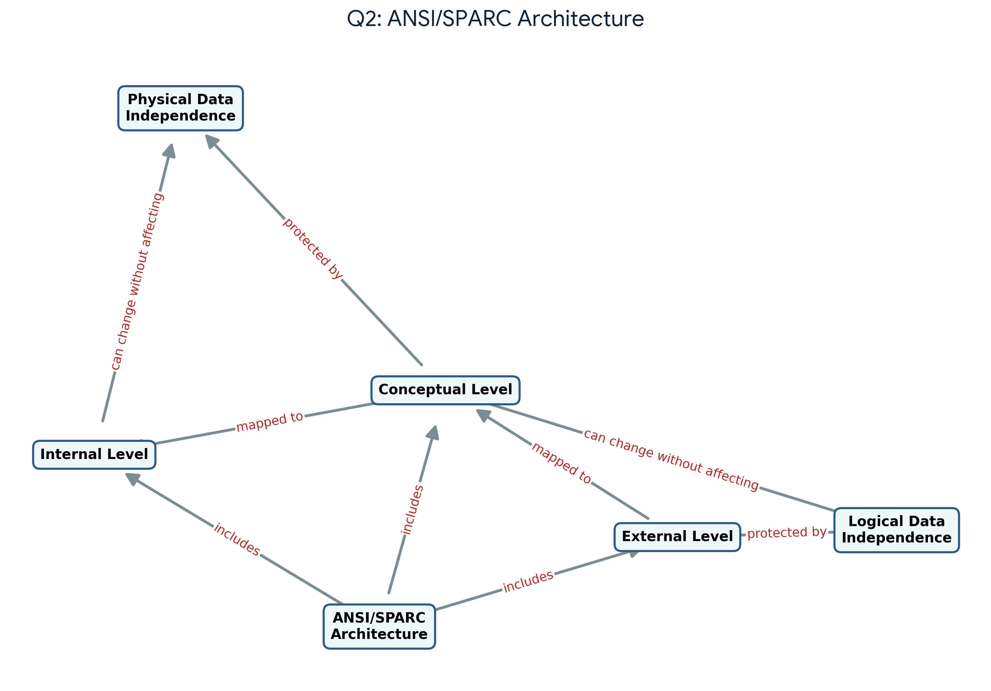
Explanation: The three-level ANSI/SPARC architecture provides a framework for data independence. The External Level contains user views, the Conceptual Level represents the logical structure of the entire database, and the Internal Level deals with physical storage. Logical Data Independence allows changes at the Conceptual Level without affecting External views. Physical Data Independence allows changes at the Internal Level without altering the Conceptual schemas.

3. Map the relationship between file-based systems and database systems, highlighting the problems solved by DBMS.
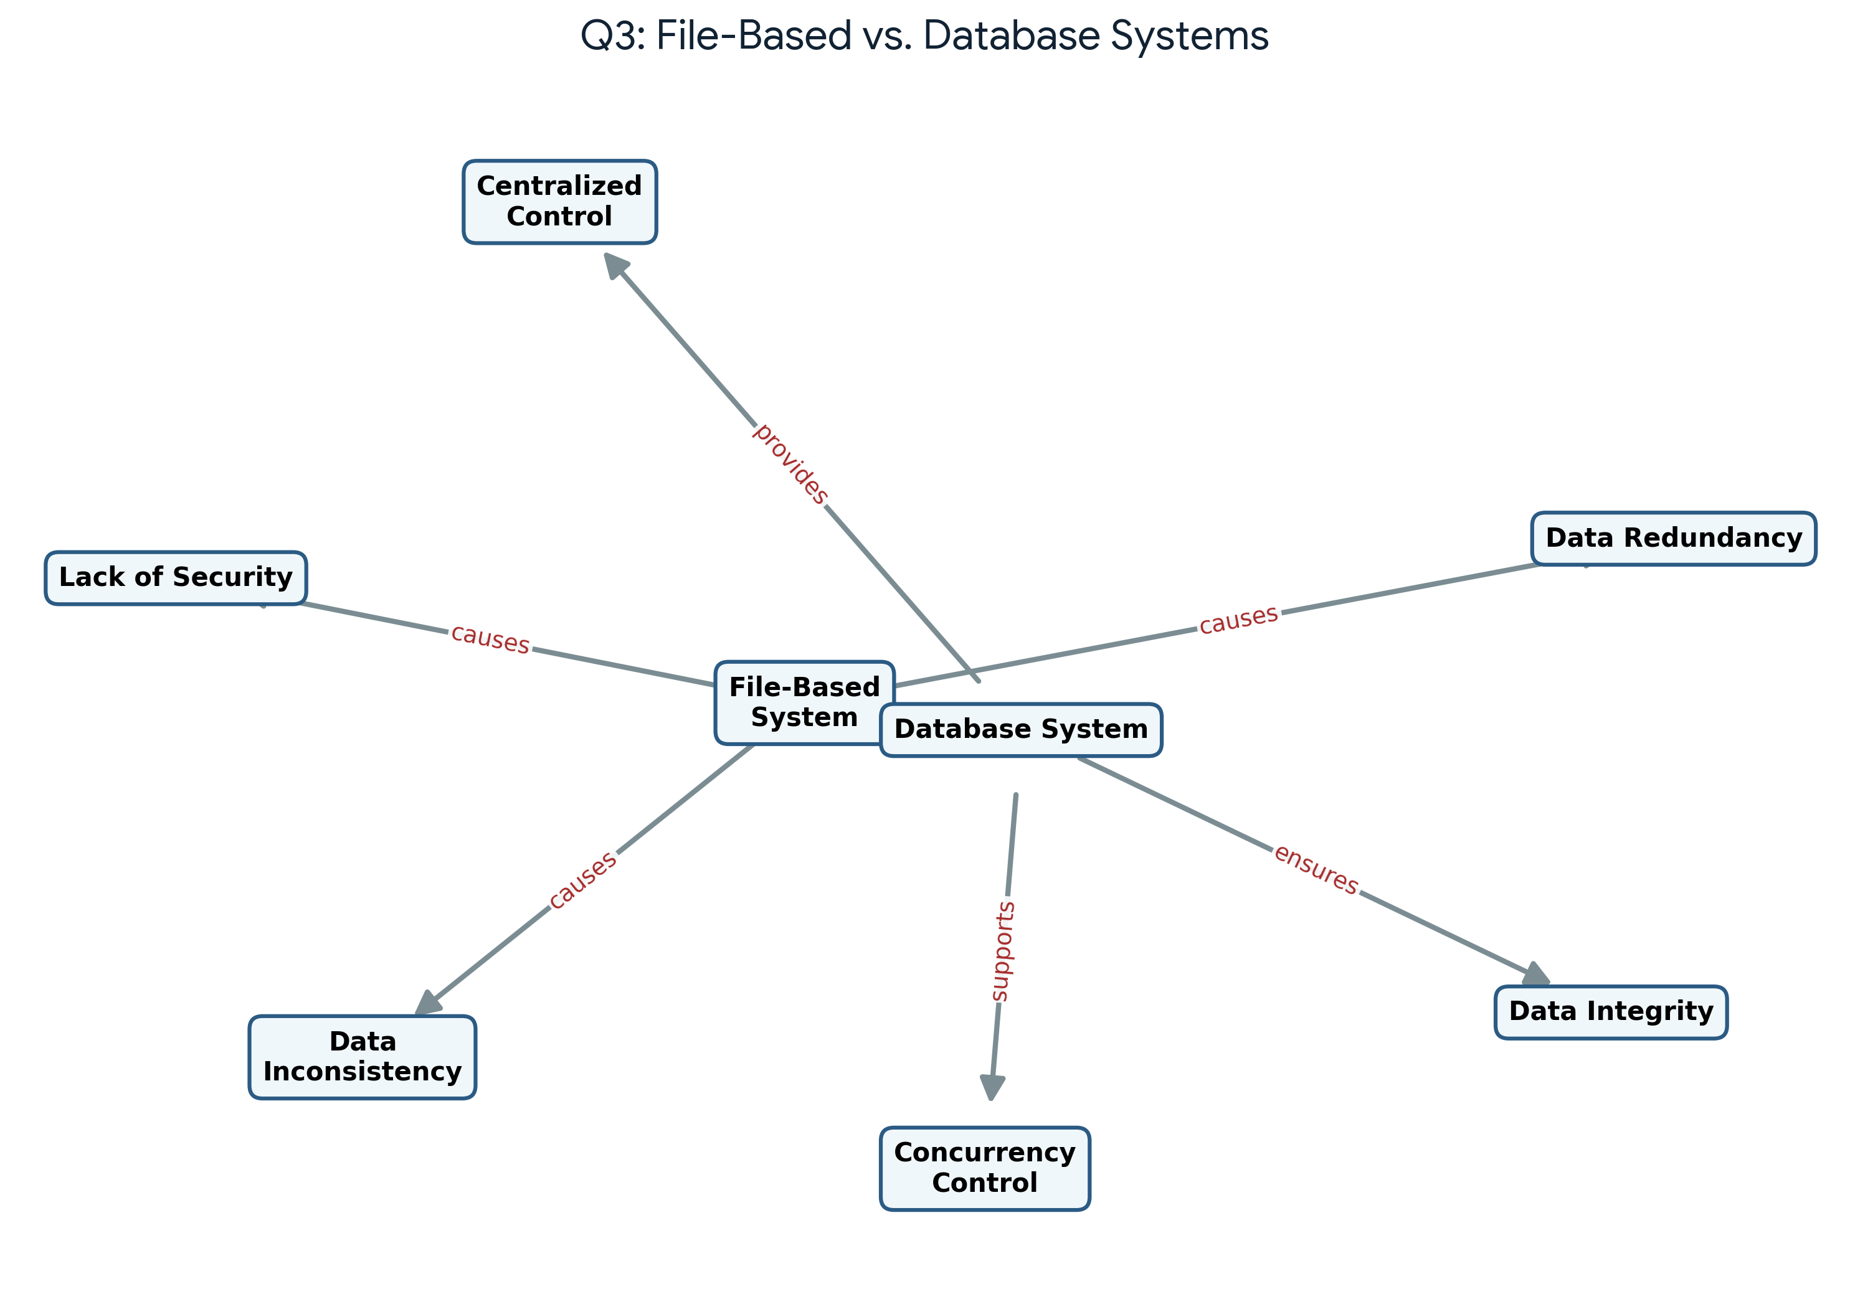
Explanation: This map contrasts traditional File-Based Systems with Database Management Systems. File-Based Systems inherently suffer from data redundancy, inconsistency, and poor security due to decentralized data silos. The Database System solves these issues by acting as a central repository, providing mechanisms for centralized control, ensuring data integrity across all applications, and supporting safe concurrent access to the data.

4. Design a concept map for ER diagram components: entity, weak entity, attribute types, relationship types, and participation constraints.
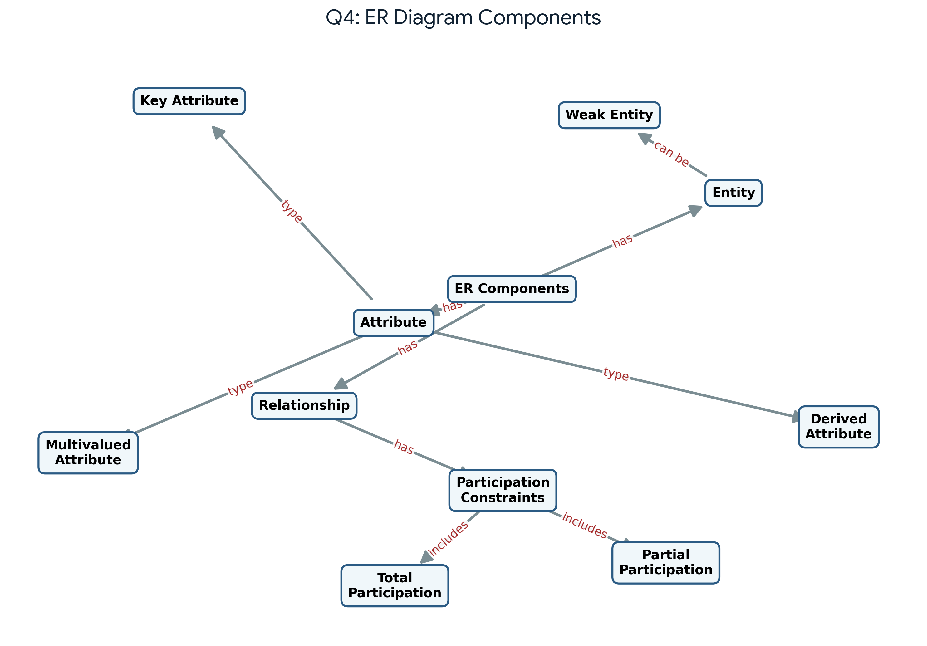
Explanation: This diagram breaks down the fundamental components of an Entity-Relationship (ER) model. Entities can be strong or weak (depending on a separate entity for identification). Attributes are categorized into types like Key (unique identifier), Derived (calculated from other data), and Multivalued. Relationships define how entities interact and include Participation Constraints, specifying whether an entity's participation is Total (mandatory) or Partial (optional).

5. Construct a concept map comparing Hierarchical, Network, and Relational data models with their key properties.
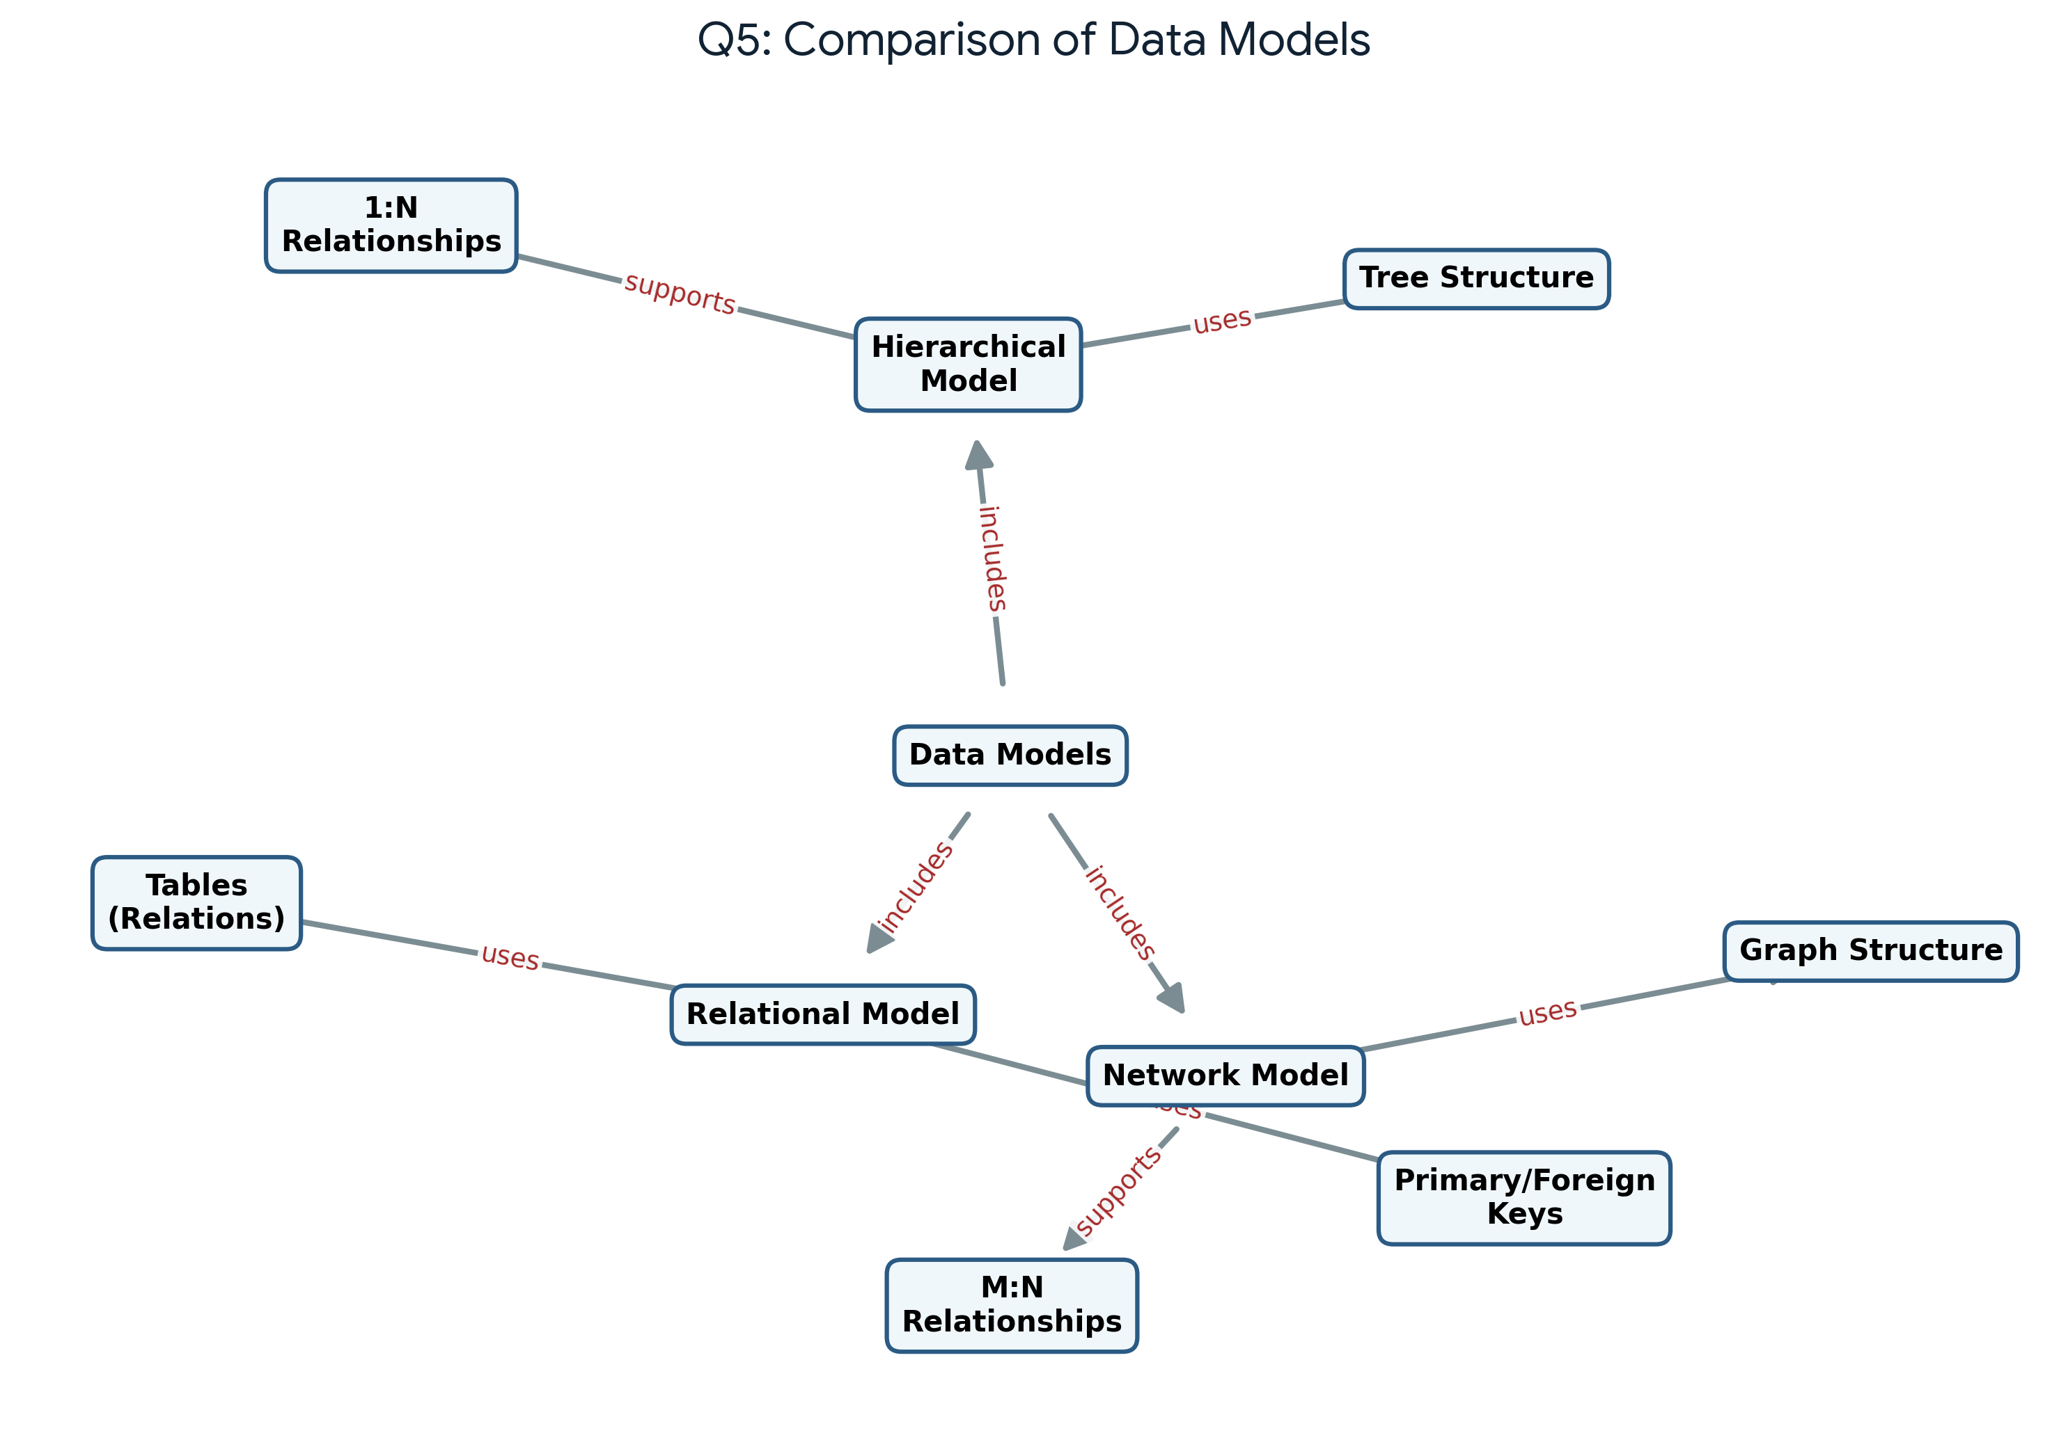
Explanation: The evolution of Database Data Models is illustrated here. The Hierarchical Model organizes data in a rigid tree structure, optimal for 1:N (One-to-Many) relationships. The Network Model utilizes a graph structure, enabling complex M:N (Many-to-Many) relationships. The modern Relational Model provides the highest flexibility by storing data in tabular formats (relations) and linking them via Primary and Foreign keys.

6. Develop a concept map for the EER model showing how it extends the basic ER model with generalization, specialization, and aggregation.
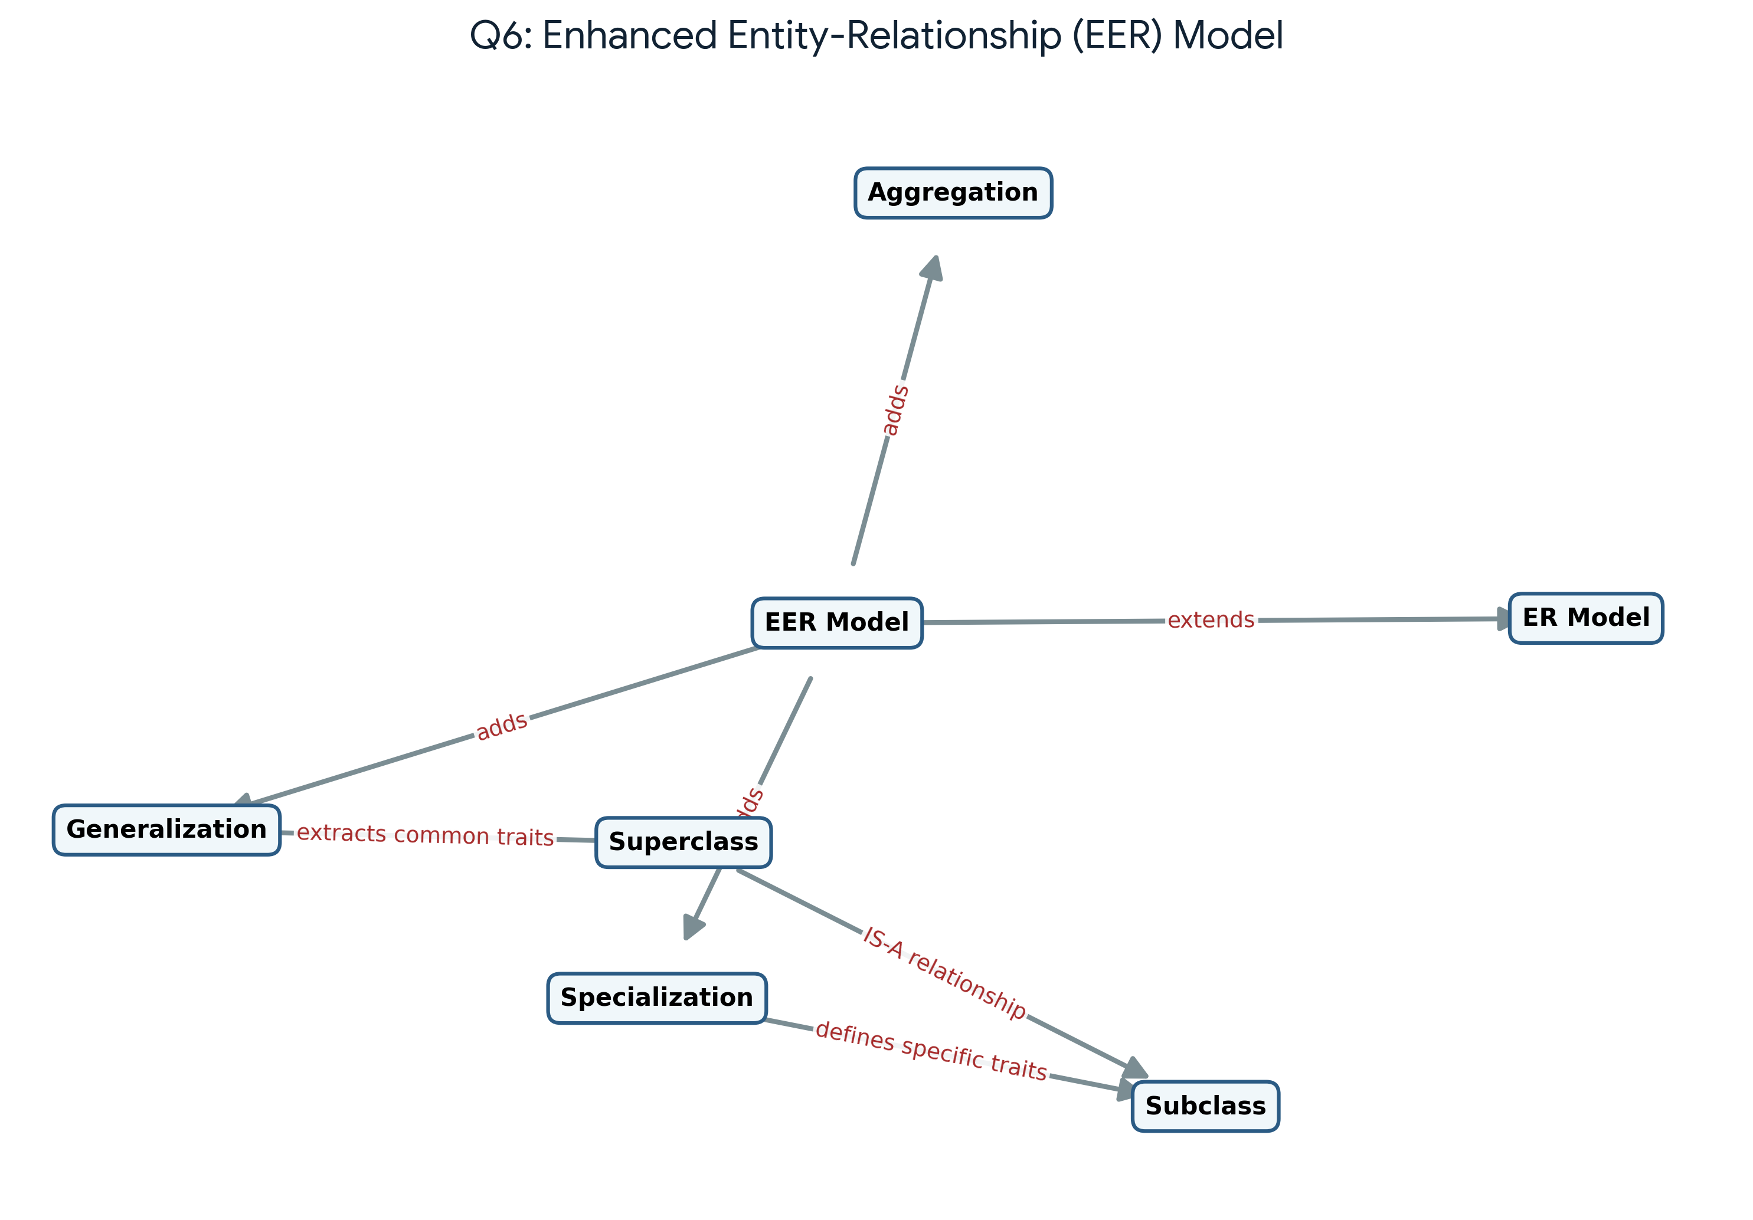
Explanation: The Enhanced Entity-Relationship (EER) model builds upon the traditional ER model by introducing advanced object-oriented concepts. It adds Generalization (bottom-up process grouping subclasses into a superclass), Specialization (top-down process creating detailed subclasses from a superclass), and Aggregation (treating a relationship as an entity). These facilitate complex data structuring and inheritance mapping.

7. Create a visual concept map for the DBMS software architecture, illustrating the flow from user request to data retrieval.
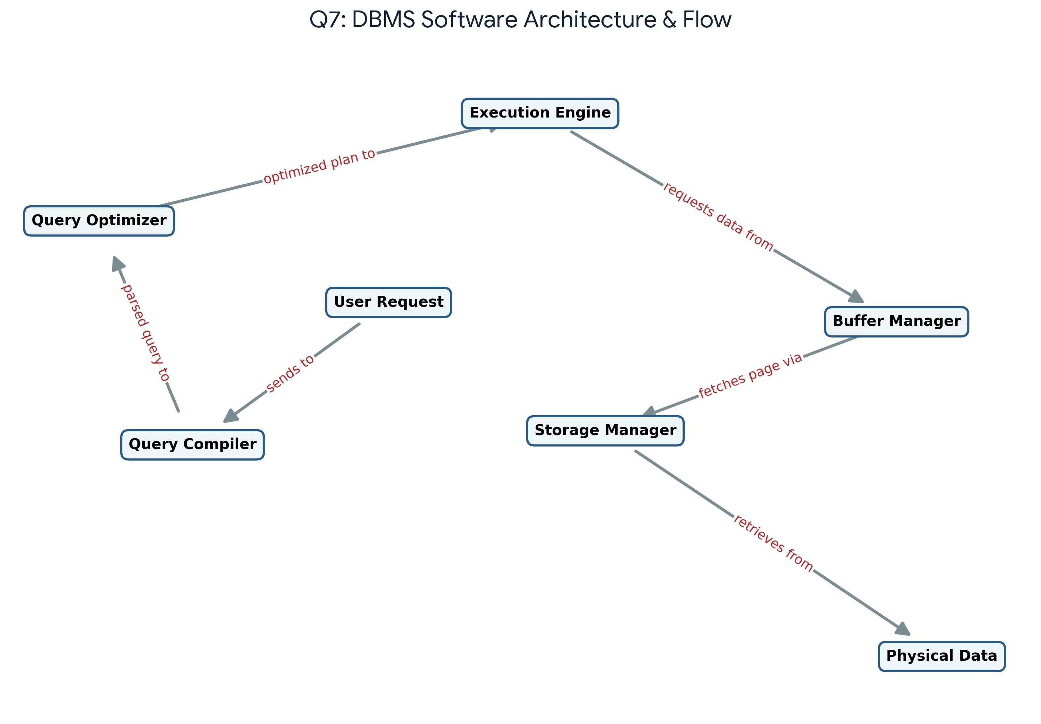
Explanation: This map illustrates the internal pipeline of a Database Management System when processing a user request. The request is first parsed by the Query Compiler, then passed to the Query Optimizer to formulate the most efficient execution plan. The Execution Engine runs this plan, interfacing with the Buffer Manager and Storage Manager to fetch the required blocks of Physical Data efficiently from disk to memory.

8. Map the data models discussed in CO1 to real-world applications and explain the suitability of each model.
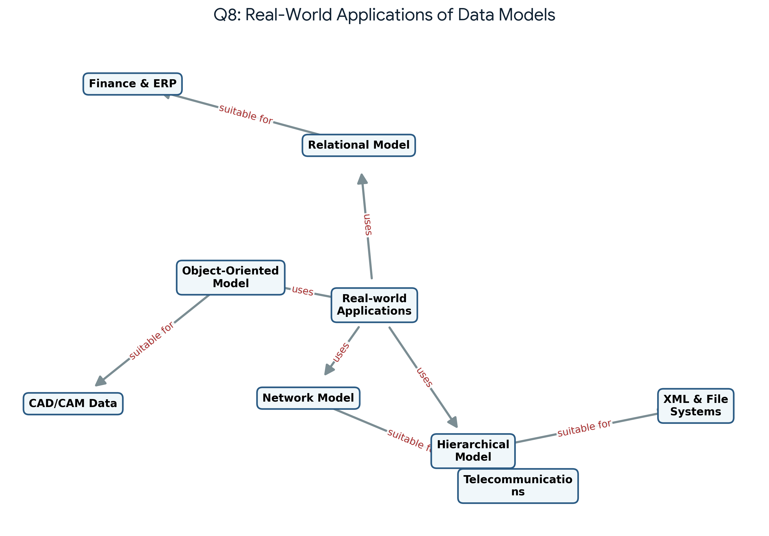
Explanation: Different data models serve specific real-world applications best based on their structure. The Relational Model is highly suited for Finance and ERP systems due to data integrity and querying flexibility. The Hierarchical Model maps perfectly to XML documents and operating system file structures. Network Models are effective in telecommunications for complex routing networks, and Object-Oriented models excel in complex structural data like CAD/CAM systems.

9. Construct a concept map for schemas and instances, showing how they relate to physical and logical data independence.
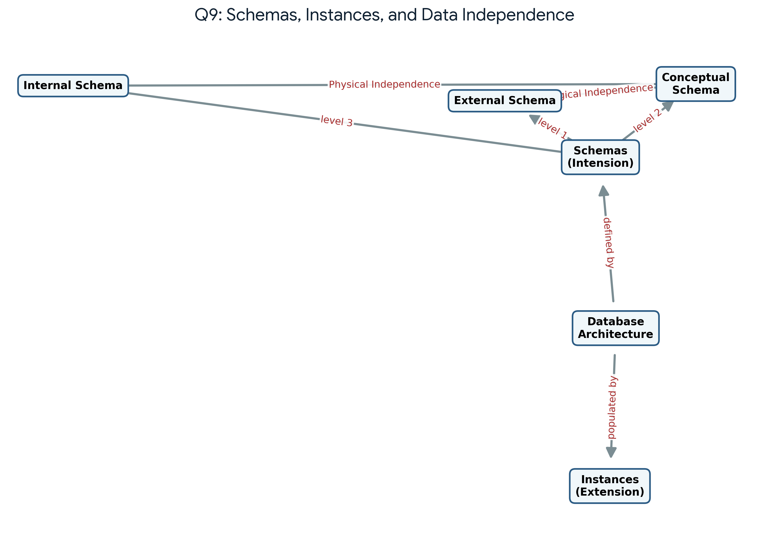
Explanation: This map clarifies the distinction between Schemas (the static design or Intension) and Instances (the dynamic snapshot of data or Extension). It maps the three schema levels—External, Conceptual, and Internal. The separation between External and Conceptual schemas grants Logical Data Independence, whereas the gap between Conceptual and Internal schemas provides Physical Data Independence.

10. Design a concept map for the roles and responsibilities in a DBMS environment: DBA, End User, Application Developer.
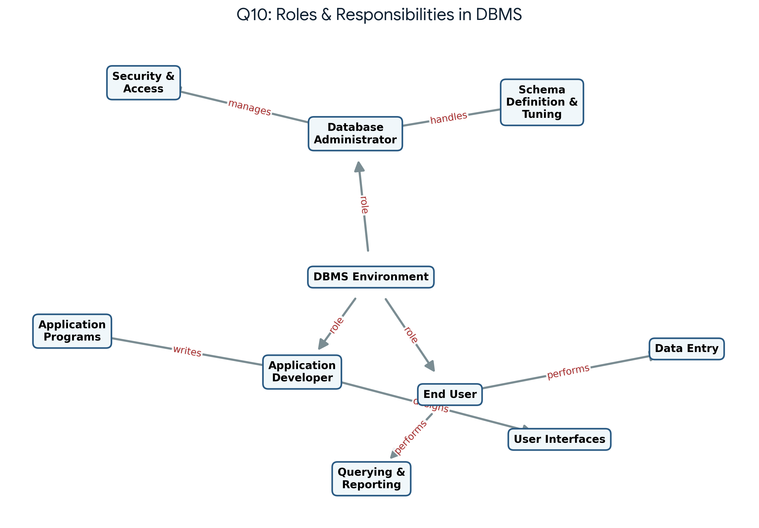
Explanation: In a typical DBMS environment, several distinct roles operate interactively. The Database Administrator (DBA) oversees the entire system, handling schema design, performance tuning, and access security. Application Developers write code and build graphical user interfaces (GUIs) to interface with the data. Finally, End Users utilize these applications to perform daily operational tasks like data entry, querying, and generating reports.

